Moving Objects in Predtool via the Backend

Below (Fig 1) is the Default Visit List view that comes in start. If you wanted to add an additional “Box” of information there is limited room. One solution is to place the information over to the right hand side next to the Patient relationships box and have the remainder of the box overhang past the right side of the edge of the tool. If you try to manually do this the new box will “jump” back to the left so that the entire box is in the viewing area of the predtool. (See Fig 2)

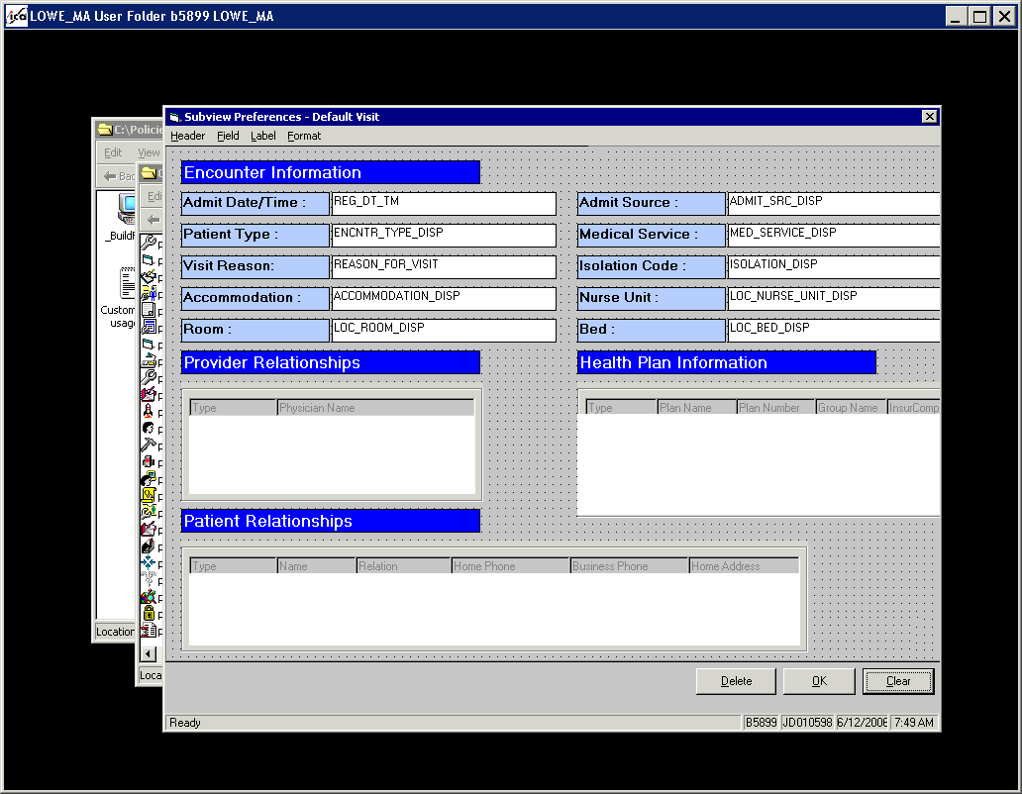
Fig 1
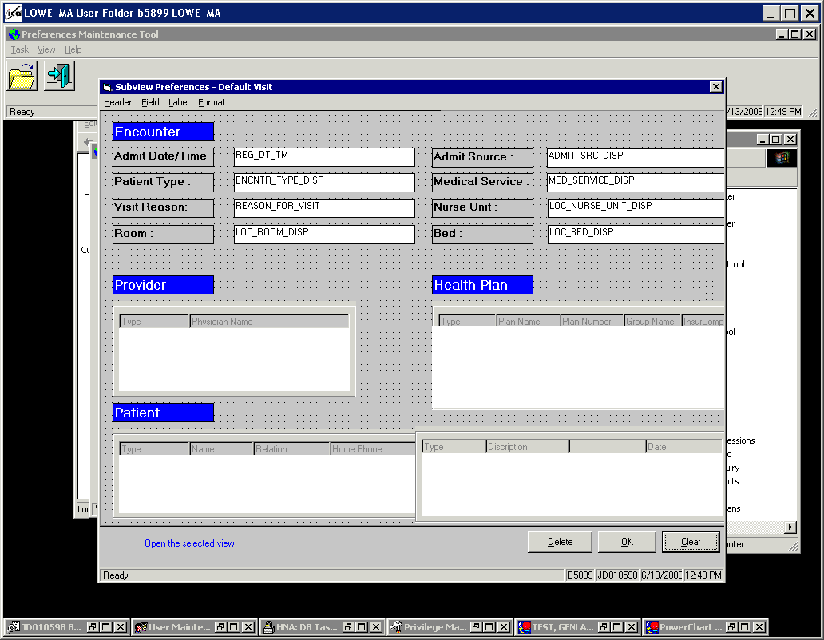
Fig 2

After making this change if you go to PowerChart (Fig 3) you can see how these boxes now overlap and this is not usable.

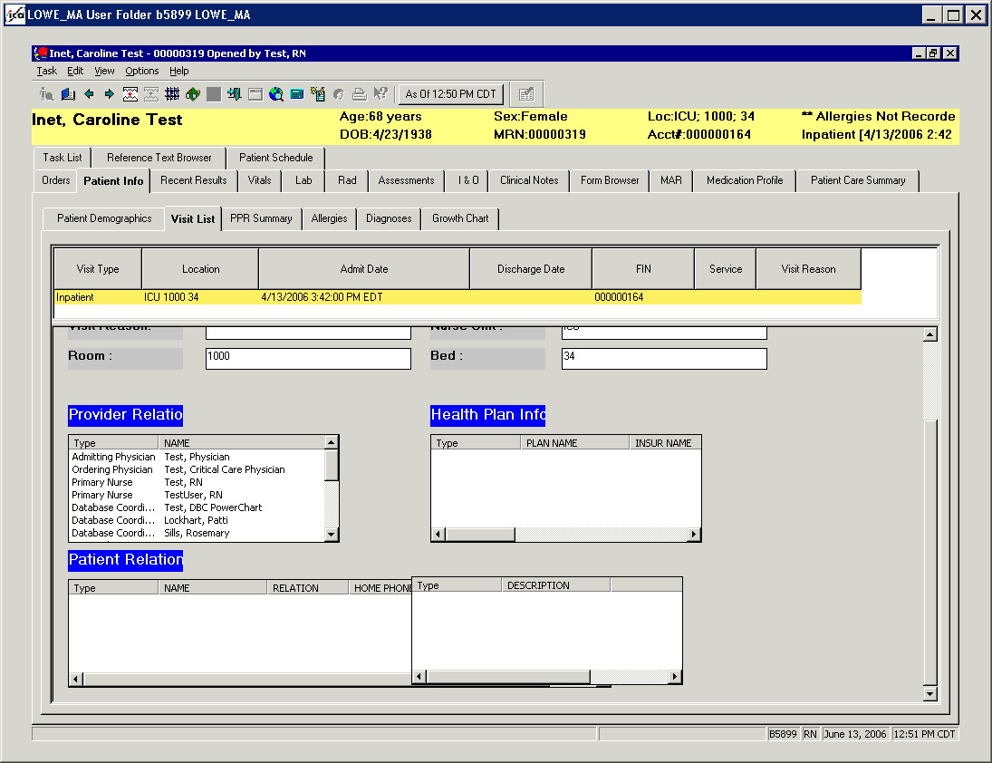
Fig 3
In order to move the Box to the correct location you will need to use the following back end commands.

1. SELECT * FROM PREDEFINED_PREFS GO
Find the name of your view in the Name Column. Copy the Predefined_prefs_id for that row.

Ex. SELECT * FROM PREDEFINED_PREFS GO
PREDEFINED_PREFS_ID PREDEFINED_TYPE_MEANING
590205 VISITVIEW

2. SELECT * FROM NAME_VALUE_PREFS WHERE PARENT_ENTITY_ID = 2358138.00 ORDER BY PVC_NAME GO
In the pvc_name column, look for the rows with pvc_names that say ALLFIELD1, ALLFIELD2, etc.
Each of these rows represents an all box in your view. By looking at the pvc_value for the row you can identify which row represents each box. Pick the row for the box that you want to move (or you can also change the size of the box)

Ex: SELECT * FROM NAME_VALUE_PREFS WHERE PARENT_ENTITY_ID = 1661892 ORDER BY PVC_NAME GO

NAME_VALUE_PREFS_ID PVC_NAME PVC_VALUE
1533765.00 ALLFIELD1 399,16,EP_RELTNqual_cnt,EP_RELTNqual,600,EP_RELTN_struct,EP_RELTN_headers
1533766.00 ALLFIELD2 239,416,HPLANqual_cnt,HPLANqual,300,HPLAN_struct,HPLAN_headers
1533767.00 ALLFIELD3 239,16,PHYSICIANqual_cnt,PHYSICIANqual,300,PHYSICIAN_struct,PHYSICIAN_headers
1533768.00 ALLFIELD4 396,395,DIAGqual_cnt,DIAGqual,300,DIAG_struct,DIAG_headers

The first number moves the object along the Y-axis, the greater the number the further down it will move. In the above example ALLFIELD1, 399, (See green circle Fig3) would be further down the screen then that of ALLFIELD2, 239, (See red circle Fig3). The next number moves the object along the X-axis, the greater the number the further right the object moves. The final number can be used to resize the length of the box. The higher you make the number, the longer the field will become causing you not to have to scroll in the field to see all the info. **Note the X and Y value is the top right corner of the object**
Ex. Above ALLFIELD1 has a number for length of 600 and the rest are 300.

3.Use the below update statement to move the objects
Update into name_value_prefs
set pvc_value = “PVC_VALUE of object you are moving”
where name_value_prefs_id = (name_value_prefs_id of object you are moving) go

Update into name_value_prefs
set pvc_value = “8”
where name_value_prefs_id = 2356240.00

Update into name_value_prefs
set pvc_name = “FIELD8”
where name_value_prefs_id =

SELECT NAME_VALUE_PREFS_ID, PVC_NAME, PVC_VALUE FROM NAME_VALUE_PREFS WHERE PARENT_ENTITY_ID = 2358138.00 ORDER BY PVC_NAME GO

Update into name_value_prefs set pvc_Value = “35,6,Visit Number:”
Where name_value_prefs_id = 2358315.00 go
Update into name_value_prefs set pvc_value =”68,6,Visit Type:”
Where name_value_prefs_id = 2358316.00 go
Update into name_value_prefs set pvc_value =”101,6,Clinical Unit:”
Where name_value_prefs_id= 2358317.00
Update into name_value_prefs set pvc_value =”134,6,Account Class:”
Where name_value_prefs_id = 2358318.00
Update into name_value_prefs set pvc_value =”167,6,Lenght of Stay (in days):” Where name_value_prefs_id = 2358319.00
Update into name_value_prefs set pvc_value= “231,6,Discharge Date/Time:”
Where name_value_prefs_id =2358320.00

Update into name_value_prefs set pvc_NAME = “LABEL1”
Where name_value_prefs_id = 2358315.00 go
Update into name_value_prefs set pvc_NAME =”LABEL2”
Where name_value_prefs_id = 2358316.00 go
Update into name_value_prefs set pvc_NAME =”LABEL3”
Where name_value_prefs_id= 2358317.00 GO
Update into name_value_prefs set pvc_NAME =”LABEL4”
Where name_value_prefs_id = 2358318.00 GO
Update into name_value_prefs set pvc_NAME =”LABEL5” Where name_value_prefs_id = 2358319.00 GO
Update into name_value_prefs set pvc_NAME= “LABEL6”
Where name_value_prefs_id =2358320.00 GO

2358323.00 FIELD1 68,192,ENCNTR_TYPE_DISP
2358324.00 FIELD2 101,188,MED_SERVICE_DISP
2358325.00 FIELD3 134,188,FINANCIAL_CLASS_DISP
2358326.00 FIELD4 167,188,DAYOFSTAY
2358327.00 FIELD5 231,192,DISCH_DT_TM
2358328.00 FIELD6 200,192,DISCH_DISPOSITION_DISP
2358329.00 FIELD7 263,192,DISCH_TO_LOCTN_DISP

In the example above we need to move the box that was added to the right so they do not overlap. Use the following update statement:

Update into name_value_prefs
set pvc_value = “399,645,DIAGqual_cnt,DIAGqual,300,DIAG_struct,DIAG_headers”
where name_value_prefs_id = 1533768 go
Below we see how this view now looks in the Predtool (Fig4). The box that was added to begin with now is moved to the right and moves off the viewing screen. In Fig5 we can see how this looks in PowerChart. You can see that there is space between the 2 boxes in PowerChart but not in the Predtool, therefore always check PowerChart to make sure it looks the way it is desired.
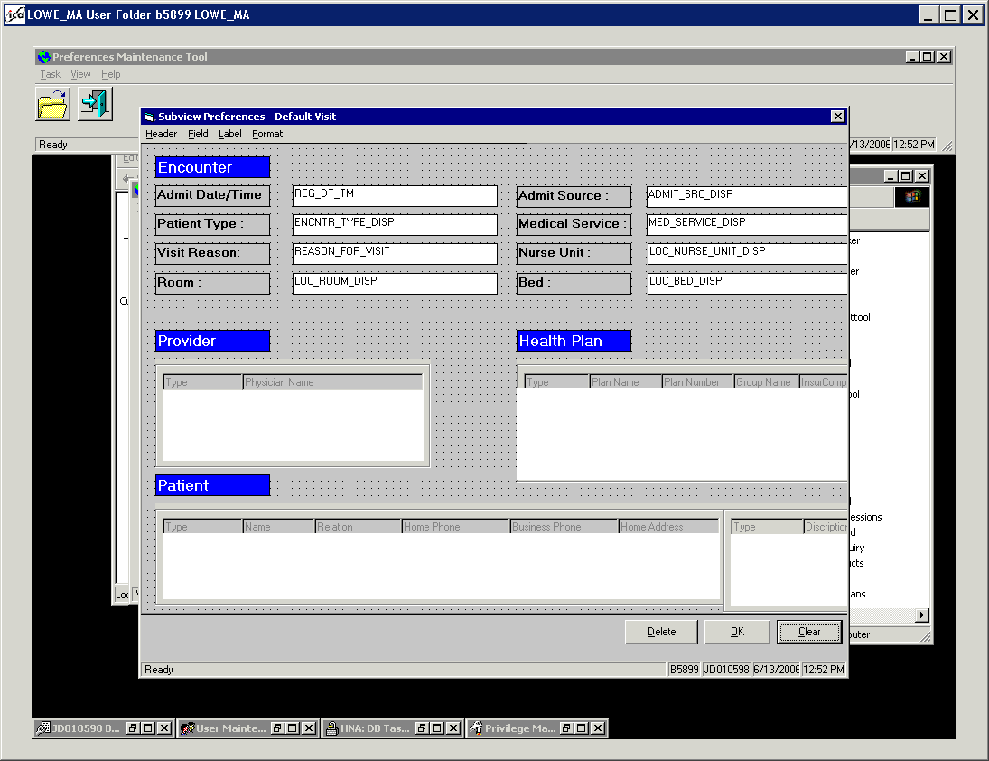
Fig 4
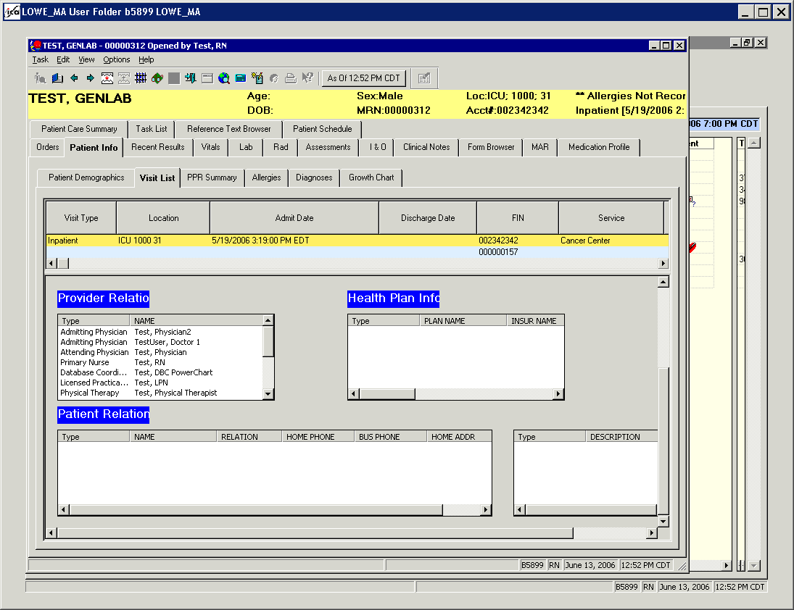
Fig 5

This can also be used to align smaller objects like Labels instead of the touch and go of moving the object by hand in the PredTool.

This is what would be used to position a label over the added box and line it up with the Label of Patient Relationship.

SELECT * FROM NAME_VALUE_PREFS WHERE PARENT_ENTITY_ID = 590205 ORDER BY PVC_NAME GO

NAME_VALUE_PREFS_ID PVC_NAME PVC_VALUE
1533905.00 ALLFIELD1 399,16,EP_RELTNqual_cnt,EP_RELTNqual,600,EP_RELTN_struct,EP_RELTN_headers
1533906.00 ALLFIELD2 239,416,HPLANqual_cnt,HPLANqual,300,HPLAN_struct,HPLAN_headers
1533907.00 ALLFIELD3 239,16,PHYSICIANqual_cnt,PHYSICIANqual,300,PHYSICIAN_struct,PHYSICIAN_headers
1533908.00 ALLFIELD4 399,645,DIAGqual_cnt,DIAGqual,300,DIAG_struct,DIAG_headers
1533884.00 HEADER1 15,16,Encounter Information
1533885.00 HEADER2 207,16,Provider Relationships
1533886.00 HEADER3 207,416,Health Plan Information
1533887.00 HEADER4 367,16,Patient Relationships
1533888.00 HEADER5 369,649,Diagnoses

Update into name_value_prefs
set pvc_value = “367,645,Diagnoses”
where name_value_prefs_id = 1533888.00 go

**Note the NAME_VALUE_PREFS_ID will change everytime you up date the view, be sure to ALWAYS do a new select statement to get the new NAME_VALUE_PREFS_ID**
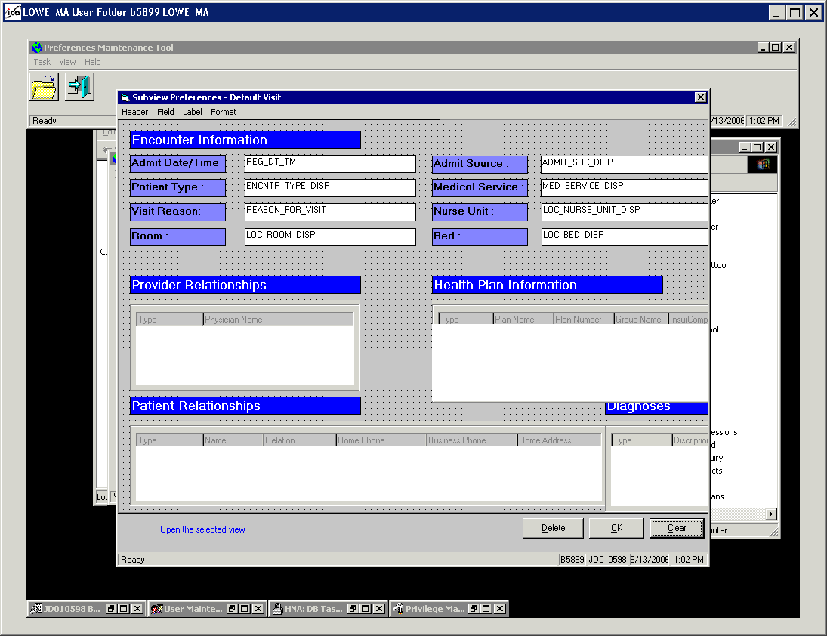
** NOTE again the PredTool view is much different from that of the PowerChart View**
sd